By: Diego Langeveldt

Grade: 11

Year: 2022

Table Of Contents:

* Key Question Page 2
* Open and Closed Ended Questions Page 3-6
* Questionnaire/Interview/Poll
* How will information be Assessed and Gathered Page 7
* Self-Evaluation Page 8
* Spell Check Page 8
* References Page 8

Key Question:

Yes, I will be able to create a café where different groups of people could come and socialise and have something to drink or light meal to eat, or just study.

|  |  |
| --- | --- |
| **Question 1** | **Would you go to just drink something and chat** |
| Type of source | u |
| Answer to question | u |
| How information will be used | To know if this is viable |
| Citation of reference | u |
| Proof of authenticity | u |
| **Question 2** | **Would you study and have something to drink** |
| Type of source | u |
| Answer to question | Mostly yes |
| How information will be used | To know if this is viable |
| Citation of reference | u |
| Proof of authenticity | u |
| **Question 3** | **Would you study while having a drink or light meal** |
| Type of source | u |
| Answer to question | Mostly yes |
| How information will be used | To know if this is viable |
| Citation of reference | u |
| Proof of authenticity | u |

Open and closed Ended Questions:

How will information be assessed and gathered:

* Spreadsheet

The spreadsheet will be used to plan the café financially

* Database

I would use a database to gather information to help with the café and find out necessary things

* Presentation

I’d use it to promote the café and get people’s attention by advertising

Self-Evaluation:

|  |  |  |
| --- | --- | --- |
| **Evidence** | 🗹 🗷 | **Comment** |
| The description of the problem describes what is expected in the project. | 🗹 |  |
| A main question is formulated. | 🗹 |  |
| A variety of questions are formulated the questions support the main question. | 🗹 |  |
| Questions are categorised according to:  Open-ended/closed-ended  Question type  Method of gathering information  Sources  Keywords | 🗹 |  |
| Reference list | 🗹 |  |
| Run spell check – screen dump evidence of spelling check | 🗹 |  |

Spell Check:

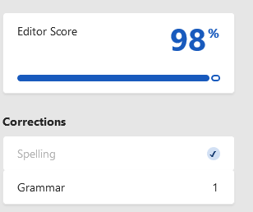

References:

**Logo:** <https://myop2020.sfo2.digitaloceanspaces.com/wp-content/uploads/2019/05/24110306/38f311e394dac319dcd03c1ada3614a4.png>